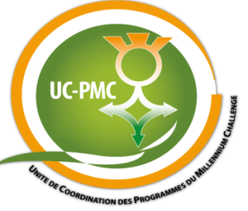
REQUEST FOR PROPOSALS
RFP/UC-PMC/Niger/QCBS/07
SELECTION OF A CRA GRANTS MANAGER
Sollicitation Addendum
Addendum N° | 2
Addendum Date | July 14th , 2017
Request For Proposals N° | RFP/UC-PMC/Niger/QCBS/07
Name of the assignment | CRA Grants Manager Services
Purchaser | UC-PMC / MCA-Niger

To All:
Below are changes and or clarifications for the RFP/UC-PMC/Niger/QCBS/07. This addendum forms a part of the Request For Proposals and modifies the original Notice and PDS (Proposal Data Sheet) as noted below:

ITC 8.1 | Clarifications may be requested by e-mail not later than July 15th, 2017.  Responses will be issued to all Consultants not later than July 21st, 2017.  The address for requesting clarifications is:  Unité de Coordination des Programmes du Millennium Challenge  Avenue du Monio Issa Beri / Commune II, BP:738 Niamey-Niger,  Telephone: (+227) 20 35 08 15/16, Fax: (+227) 20 35 08 18 -  Email: tmbonye@crownagentsusa.com and must be copied to s.gourouza@ucpmc.ne and procurement@ucpmc.ne
ITC 17.7 | Ensure the outer label (or carton) of the Proposal includes this statement:  “Do NOT Open Before July 31st, 2017 at 11:00 am Niamey/Niger time. Open ONLY In Presence of the Official Appointed.”
ITC 18.1 | Proposals must be submitted no later than 11:00 am local time in Niamey, Niger equivalent to 10:00 am UT (Universal Time) on July 31st, 2017.
ITC 20.1 | The Proposal opening shall take place at UC-PMC Office at the same address as for the submission of Proposals at 11:15 am local time in Niamey, Niger on July 31st, 2017.

