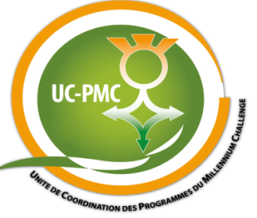
REQUEST FOR PROPOSALS
RFP/UC-PMC/Niger/QCBS/07
SELECTION OF A CRA GRANTS MANAGER
Sollicitation Addendum
Addendum N° | 4
Addendum Date | October 12th , 2017
Request For Proposals N° | RFP/UC-PMC/Niger/QCBS/07
Name of the assignment | CRA Grants Manager Services
Purchaser | UC-PMC / MCA-Niger

To All:
Below are changes and or clarifications for the RFP/UC-PMC/Niger/QCBS/07. This addendum forms a part of the Request For Proposals and modifies the original Notice and PDS (Proposal Data Sheet) as noted below:

ITC 8.1 | The address for requesting clarifications is:  Unité de Coordination des Programmes du Millennium Challenge  Avenue du Monio Issa Beri / Commune II, BP:738 Niamey-Niger,  Telephone: (+227) 20 35 08 15/16, Fax: (+227) 20 35 08 18 -  Email: fbanlongar@crownagentsusa.com and must be copied to mamane.annou@yahoo.com and clarifications.procurement@ucpmc.ne

