Republic of Niger
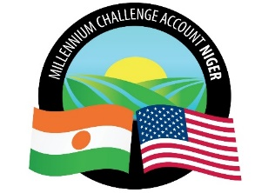
Millennium Challenge Account Niger
(MCA-Niger)

SPECIFIC PROCUREMENT NOTICE (SPN)

Country | NIGER
City Locality | Niamey
Project Name | PRAPS
Procurement Title | Supply of vaccines and diluents
Procurement Ref. Number as per Procurement Plan | Réf DAO : CR/PRAPS/1/QPBS/132/20
Type of Procurement (goods, works or services as applicable) | Goods
Buyer | Millennium Challenge Account-Niger
Publication Date | September 21 th, 2020
Notice Deadline | November 10 th, 2020 at 10 AM, Niamey time

The Millennium Challenge Account-Niger (MCA-Niger) received funding from the Millennium Challenge Corporation to cover the cost of public investments in animal health through the PRAPS project and intends to apply part of the proceeds toward payments under the contract for Supply of vaccines and diluents. MCA-Niger through its Procurement Agent, invite eligible bidders to submit bids for the acquisition of laboratory equipment.

Bidding will be conducted through the Quality Price Based Selection (QPBS) procedures as specified in the MCC Program Procurement Guidelines (PPG), and is open to all eligible bidders as defined in the PPG.

Bids must be submitted electronically and, in the manner, indicated in point IS 25.1, of the Specific Data as mentioned in the (SBD), no later than Thursday, November 10 th, 2020 at 10 AM, Niamey time. Late bids will be rejected.
Bids will be publicly opened on Thursday November 10 th, 2020 at 12h 30 PM, at (local time) in the presence of the bidders and in the manner indicated in point IS 28.1, of the Specific data as mentioned in the (DPAO). The minutes of the opening of technical offers will be sent to bidders who have submitted their offers on time.

Bidders interested in submitting a bid should express their interest by sending an email including their full contact details to the contact point below. This requires Bidders to receive updates regarding this IAS.

Contact Information:
E-mail: | mcanigerpa@cardno.com  copy to: procurement@mcaniger.ne
Website: | www.mcaniger.ne

