Republic of Niger
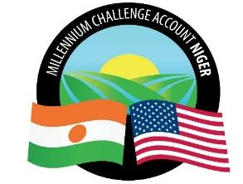
Millennium Challenge Account Niger
(MCA-Niger)

SPECIFIC PROCUREMENT NOTICE (SPN)

Country | Niger
City | Niamey
Project name | Irrigation and market access
Market title | Supply and delivery of starter kits for the rehabilitation of the Konni irrigated perimeter
Activity number according to the Procurement Plan | RIR/IPD/4/CB/334/21
Type of market | Supply of Goods
Buyer | Millennium Challenge Account-Niger
Date of Publication | February 18, 2022
Deadline date and time for submission | March 21, 2022, at 10 a.m. Niamey time

The Millennium Challenge Account of Niger (MCA-Niger) has received funding from the Millennium Challenge Corporation (MCC) to finance investments in irrigation through the "Irrigation and Market Access" project and intends to use part of this funding to make payments under the contract for the "Supply and Delivery of Starter Kits for the Rehabilitation of the Konni Irrigation perimeter".
MCA-Niger invites eligible bidders to submit bids for the supply and delivery of the goods described above.
The procurement process will be conducted through the "Competitive Bidding" method in accordance with the procedures described in the MCC Program Procurement Guidelines (PPG) and is open to all eligible bidders as defined in the PPG.

Bids must be submitted electronically as indicated in point IS25.1, of the Bid Data Sheet (BDS), no later than Monday, March 21, 2022 at 10:00 a.m, Niamey time. Late bids will be rejected.
A public opening of the bids will take place on Monday, March 21, 2022, at 11:00 a.m. Niamey time as indicated in point IS28.1 of the Bid Data Sheet. The minutes of the opening of the bids will be sent to the bidders who submitted their bids within the deadline.
Bidders interested in submitting a Bid should express their interest by sending an e-mail with their full contact details to the contact point listed below. This will allow Bidders to receive updates regarding this request for offers.
Contact address:
Email: | mcanigerpa@cardno.com  Copy to: procurement@mcaniger.ne
Website: | www.mcaniger.ne

