REPUBLIC OF NIGER
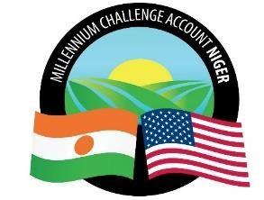
MILLENNIUM CHALLENGE ACCOUNT NIGER (MCA-NIGER)

SPECIFIC PROCUREMENT NOTICE (SPN)

Country | Niger
City | Niamey
Project name | Climate Resilient Communities Project (CRC)
Market title | Supply of vaccines and diluents
Activity number according to the Procurement Plan | DAO N°PRAPS/1/CB/451/23
Type of market | Supply of Goods
Buyer | Millennium Challenge Account-Niger
Date of Publication | May 19, 2023
Deadline date and time for submission | On June 30, 2023, at 10 :00 a.m. sharp, time of  Niamey

The Millennium Challenge Account of Niger (MCA-Niger) has received funding from the Millennium Challenge Corporation (MCC) to finance the costs of the Climate Resilient Communities (CRC) project activities and expects to apply a portion of this funding to payments made under the "Supply of Vaccines and Diluents" contract.
MCA-Niger hereby invites eligible bidders to submit their bids for the supply of the above mentioned Goods.
The procurement process will be conducted through the Competitive Bidding method in accordance with the procedures outlined in the MCC Program Procurement Guidelines (PPG) and is open to all eligible bidders as defined in the PPG.
Bids must be submitted electronically and in the manner indicated in item IS 24.1, of the Bidding
Documents Particulars (BDP) no later than, June 30, 2023, at 10 :00 a.m., Niamey
time. Late bids will be rejected.

A public opening of bids will be held on, June 30, 2023, at 11:00 a.m. Niamey time,
in the manner indicated in item IS 28.1 of Bidding Documents Particulars (BDP). The minutes
of the opening of bids will be sent to the bidders who submitted their bids within the deadline.

Interested Bidders may obtain additional information by sending an email to the following addresses:

Email: | AMEEMMCANigerPA@dt-global.com Copy to : procurement@mcaniger.ne
Website: | www.mcaniger.ne

